Name: Devanandh A B Date:28/4/25

Roll no: AM.EN.U4ECE22014

ASSIGNMENT 1  
TOPOLOGIES

1. Bus Topology:   
     
   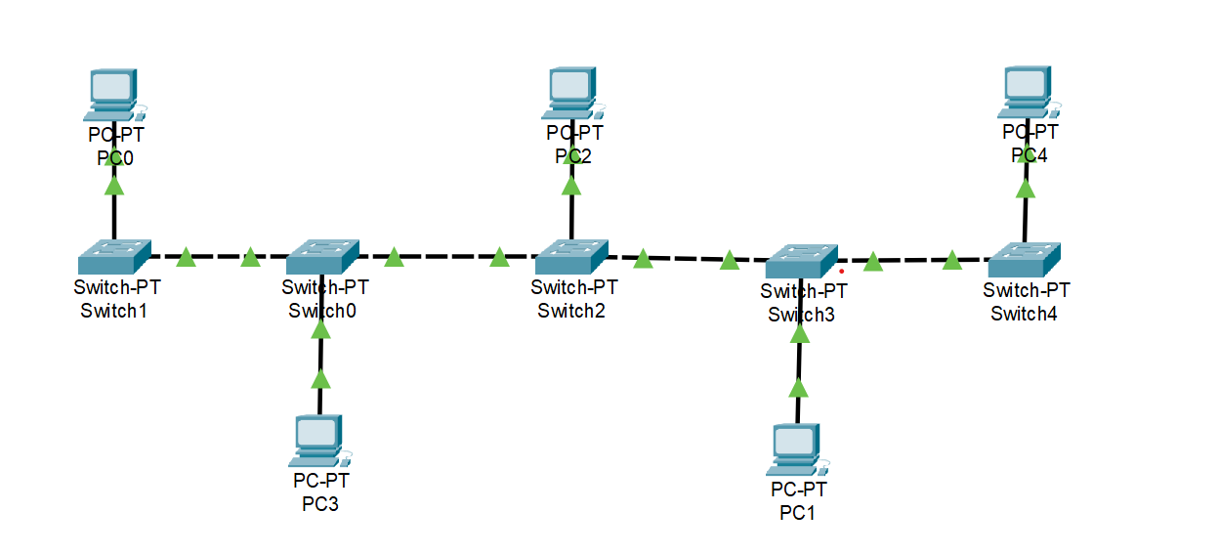
2. Ring Topology:

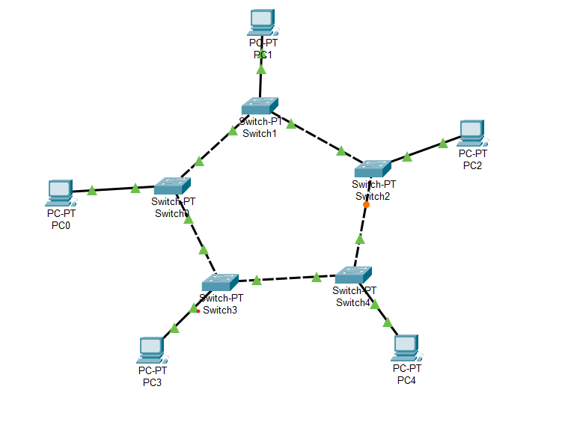

1. Mesh Topology:

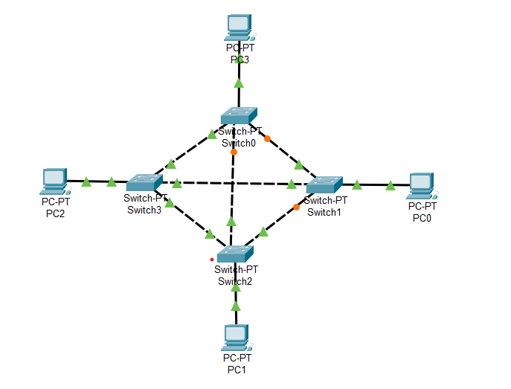

1. Star Topology:

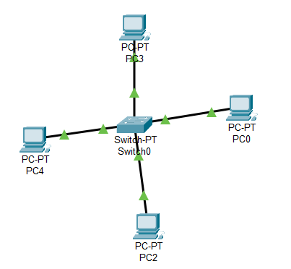

1. Tree Topology:

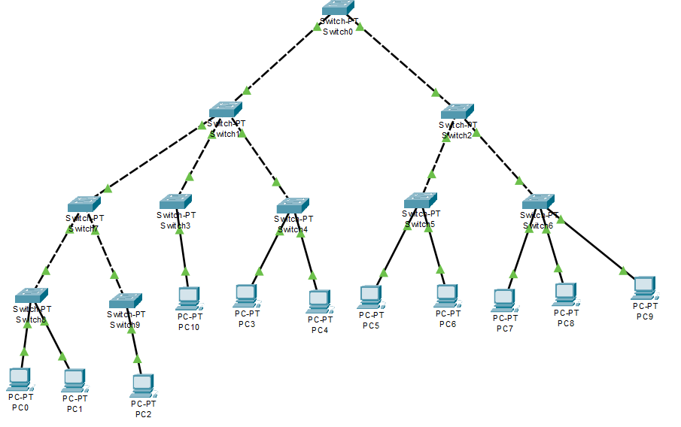

ASSIGNMENT 2:  
TOPOLOGY IMPLEMENTATION

LAN Networks with Tree, Star, and Ring Topologies :

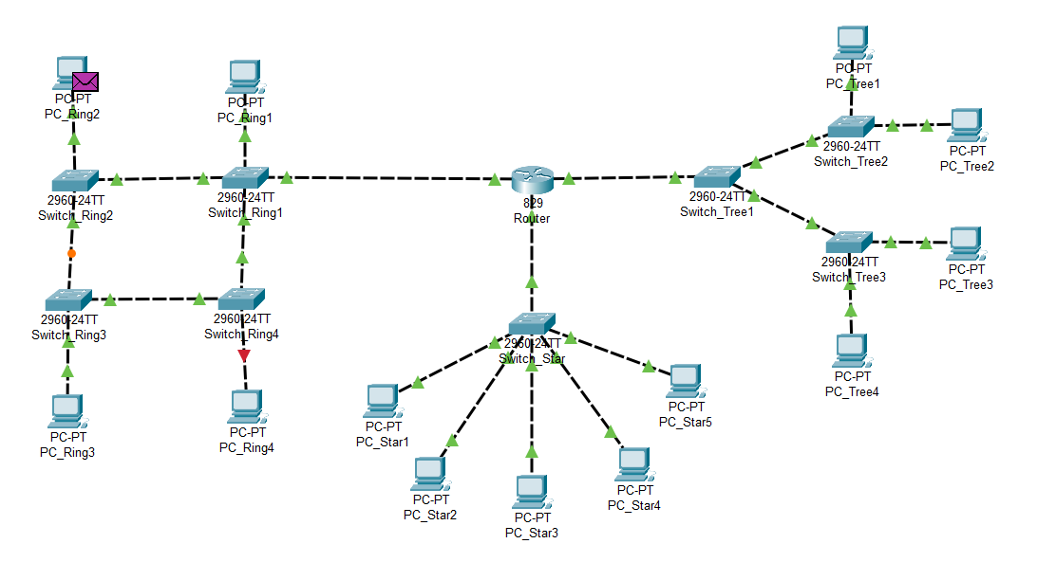

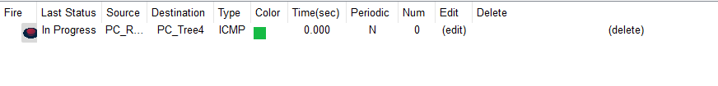

Source PC IP adress: 220.14.1.2 ( PC_Ring2 )  
Destination PC IP adress: 220.14.3.4 ( PC_Tree4 )

Ring topology: IP Addresses → 220.14.1.1 - 220.14.1.4

Star topology: IP Addresses → 220.14.2.1 - 220.14.2.5

Tree topology: IP Addresses → 220.14.3.1 - 220.14.3.4

